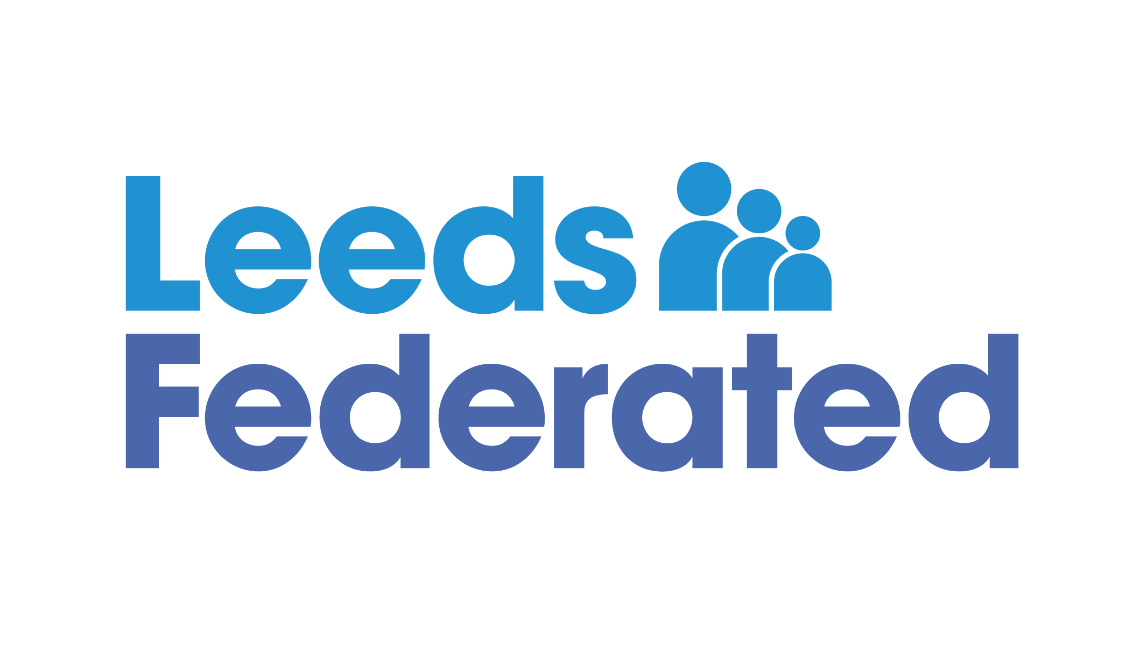
Passion|Excellence|Honesty|Innovation

Leeds Federated Fire Testing Service Standards
Leeds Federated manages fire and emergency light testing in communal areas and aims to visit each scheme every week. When one of our team carries out a fire test visit, they will make the checks listed and work to the following service standards:
The service standards you can expect:
- Make visual check at each site to ensure a safe working environment
- They will carry identification at all times
- Work within Health and Safety guidelines and safe working practices including wearing correct Personal Protective Equipment for all tasks
- Sound test to the fire alarm system within the timescales stated in your communal area
- A visual weekly test of emergency lighting. A manual switch test is also carried out on a monthly basis
- Smoke vent test if applicable
- A smoke alarm test if applicable
- Check and report on any defective fire doors
- Check all emergency and fire exit routes to ensure they are not obstructed
- Report all housekeeping issues to the Neighbourhood Officer, this includes all resident belongings that are stored in hallways, landings and under stairwells
- Removal and correct disposal of any junk mail along with any other internal litter
- Work with tenants in discouraging storage of tenant belongings in communal areas
- Complete an electronic record of attendance

If you feel the above standards have not been delivered or you have any comments on our service please contact one of our Service Managers at: ServiceManagers@lfha.co.uk or call 0113 386 1000 to speak to them about our service.

